**PROJECT NAME AND DESCRIPTION**

**GU Student Management System**

It’s a database management project in which we can maintain the online details of students.

Login as user or admin . If user login as student the he can see his details but did’t have permission to modify it. If login as Admin then they can alter any data.

Before creating account every user have to verified by admin. Admin have rights to remove any data.

**Types of E-Commerce Models**

Electronic commerce can be classified into four main categories. The basis for this simple classification is the parties that are involved in the transactions. So the four basic electronic commerce models are as follows,

**1. Business to Business**

This is Business to Business transactions. Here the companies are doing business with each other. The final [consumer](https://www.toppr.com/guides/economics/consumer-rights/) is not involved. So the online transactions only involve the [manufacturers, wholesalers, retailers](https://www.toppr.com/guides/business-studies/internal-trade/internal-trade-and-wholesale-trade/) etc.

**2. Business to Consumer**

[Business](https://www.toppr.com/guides/business-studies/nature-and-purpose-of-business/concept-and-characteristics-of-business/) to Consumer. Here the company will sell their goods and/or services directly to the consumer. The consumer can browse their websites and look at products, pictures, read reviews. Then they place their order and the company ships the goods directly to them. Popular examples are Amazon, Flipkart, Jabong etc.

**3. Consumer to Consumer**

Consumer to consumer, where the consumers are in direct contact with each other. No company is involved. It helps people sell their personal goods and assets directly to an interested party. Usually, goods traded are cars, bikes, electronics etc. OLX, Quikr etc follow this model.

**4. Consumer to Business**

This is the reverse of B2C, it is a consumer to business. So the consumer provides a good or some service to the [company](https://www.toppr.com/guides/business-laws/companies-act-2013/meaning-and-features-of-a-company/). Say for example an IT freelancer who demos and sells his software to a company. This would be a C2B transaction.

Examples of E-Commerce

* Amazon
* Flipkart
* eBay
* Olx
* Quikr

**ER DIAGRAM**

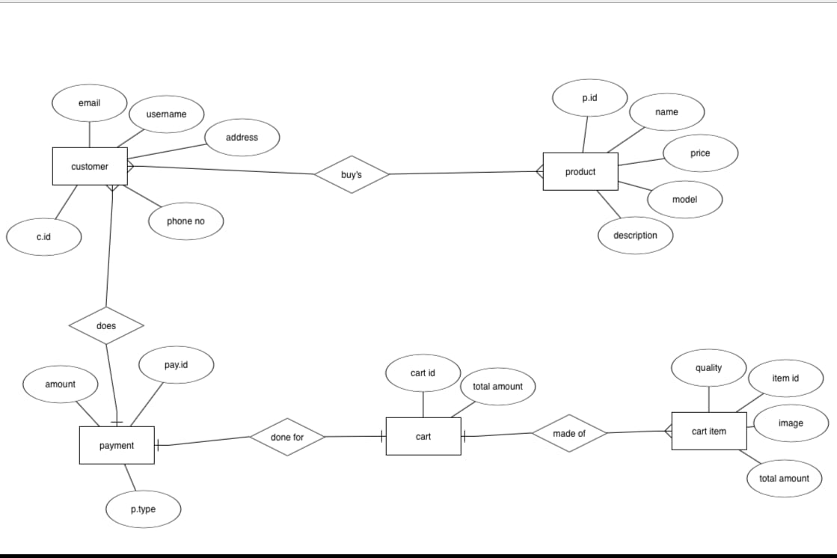

BLOCK ER DIAGRAM

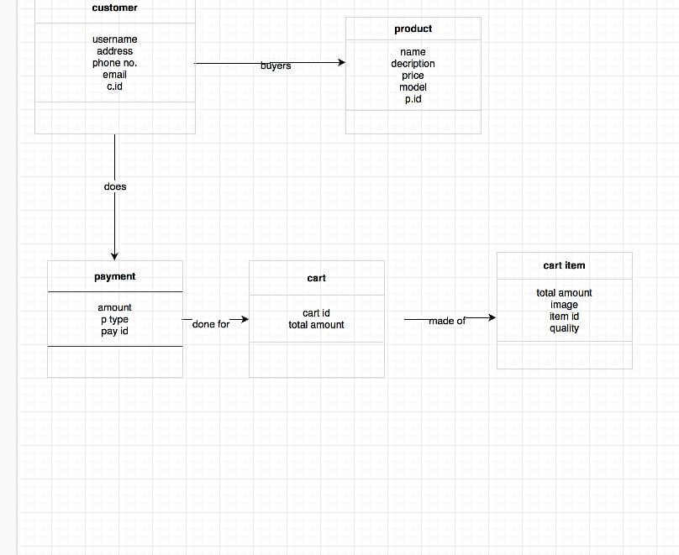

ER Table & Attributes

Customer:

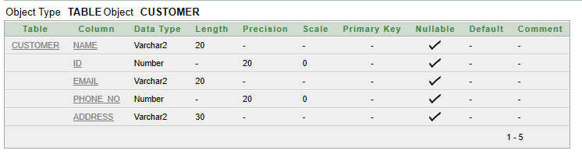

Product:

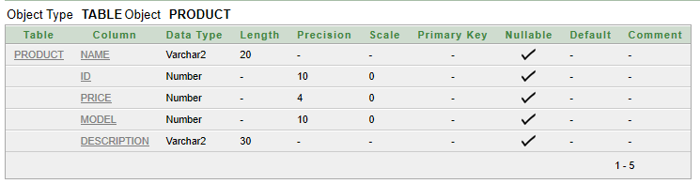

Payment:

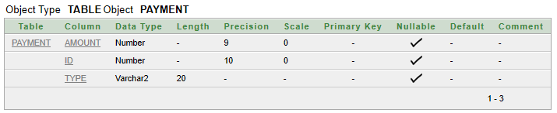

Cart:

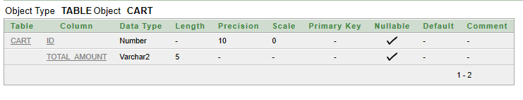

Cart_item:

